

**TRACING THE GROWTH OF THE GLOBAL COMMUNITY: A POPULATION FORECASTING ANALYSIS**

*PROJECT REPORT TEMPLATE*



**team id: *nm2023tmid05440***

**team leader:** ***p.nISHA (nm_id:70d9426f6572ad889f444f3ab6d5e252)***

**tEAM MEMBERS:**

**1. *theebiga.l***

***2. rashmi.R.K***

***3. Nanthana.n***

***TRACING THE GROWTH OF THE GLOBAL COMMUNITY: A POPULATION FORECASTING ANALYSIS***

***1 INTRODUCTION:***

*1.1* ***Overview:***

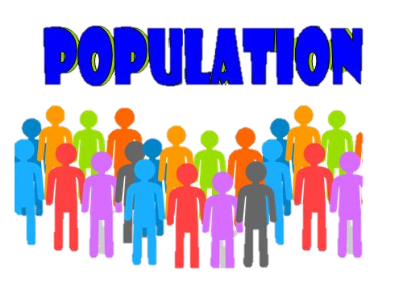The world’s population is more than three times larger than it was in the mid-twentieth century. The global human population reached 8.0 billion in mid-November 2022 from an estimated 2.5 billion people in 1950, adding 1 billion people since 2010 and 2 billion since 1998.Theworld’s population is expected to increase by nearly 2 billion persons in the next 30 years, from the current 8 billion to 9.7 billion in 2050 and could peak at nearly 10.4 billion in the mid-2080s.This dramatic growth has been driven largely by increasing numbers of people surviving to reproductive age, the gradual increase in human lifespan, increasing urbanization, and accelerating migration. Major changes in fertility rate have accompanied this growth .These trends will have far-reaching implications for generations to come.

*1.2* ***Purpose:***

* 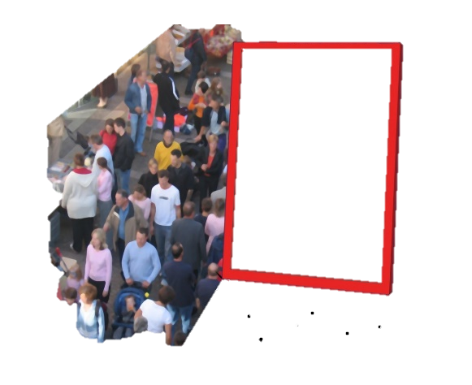The aim of The Overpopulation Project (TOP) is to study and highlight the environment impacts of overpopulation, including humane policies to end population growth around the world.
* In ecology, overpopulation is a concept used primarily in wild life management.
* Typically, an over population causes the entire population of the species in question to become weaker, as no single individual is able to find enough food or shelter. Population control is the methodology or the practice used to control and maintain the type, location and number of people that inhabit the earth.
* Quality and status of life have undergone a drastic change over a century.

***2 Problem Definition & Design Thinking***

*2.1 Empathy Map*

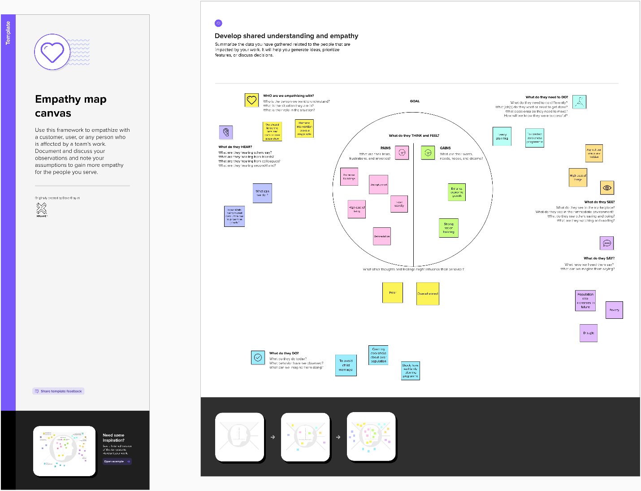

*2.2 Ideation & Brainstorming Map*

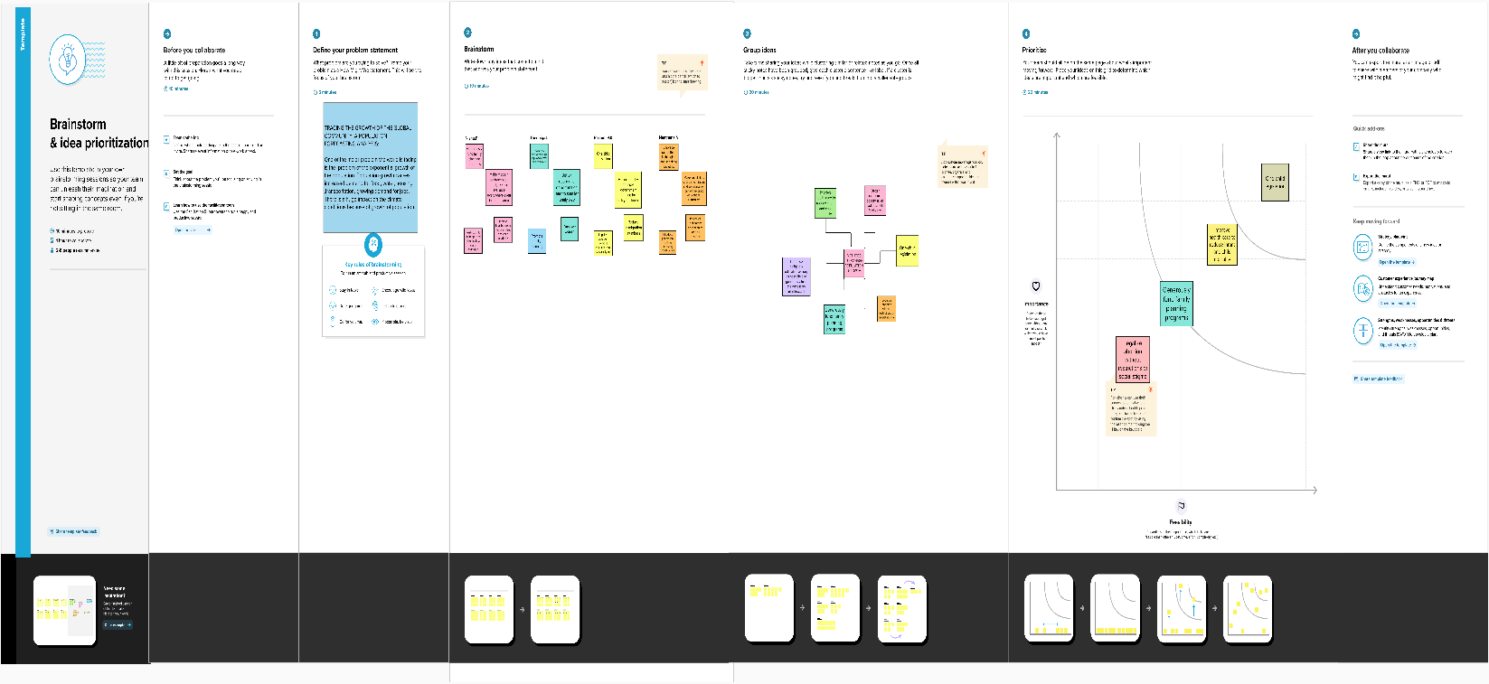

***3 Result***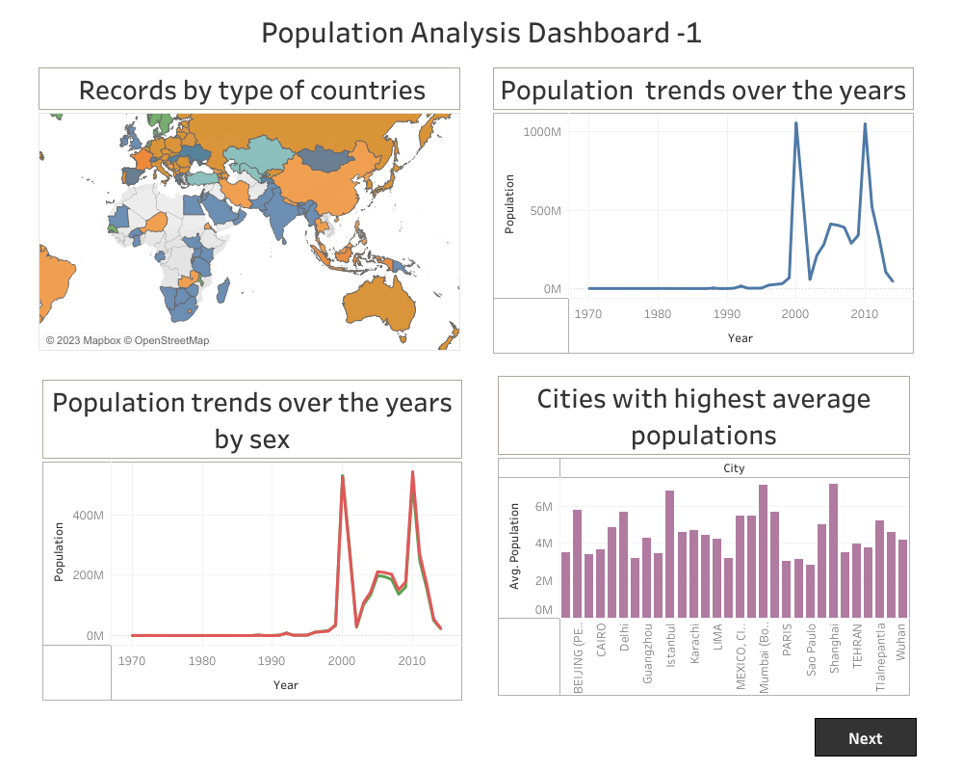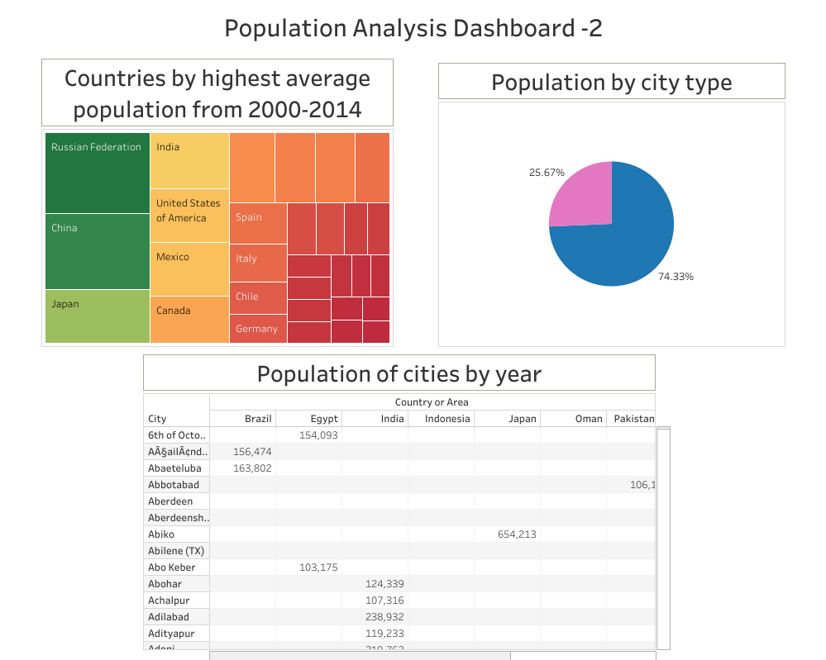

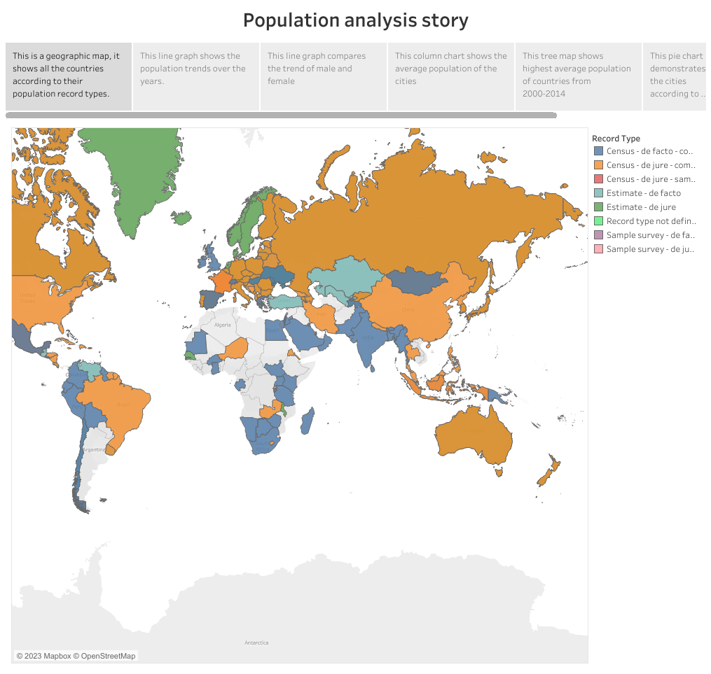

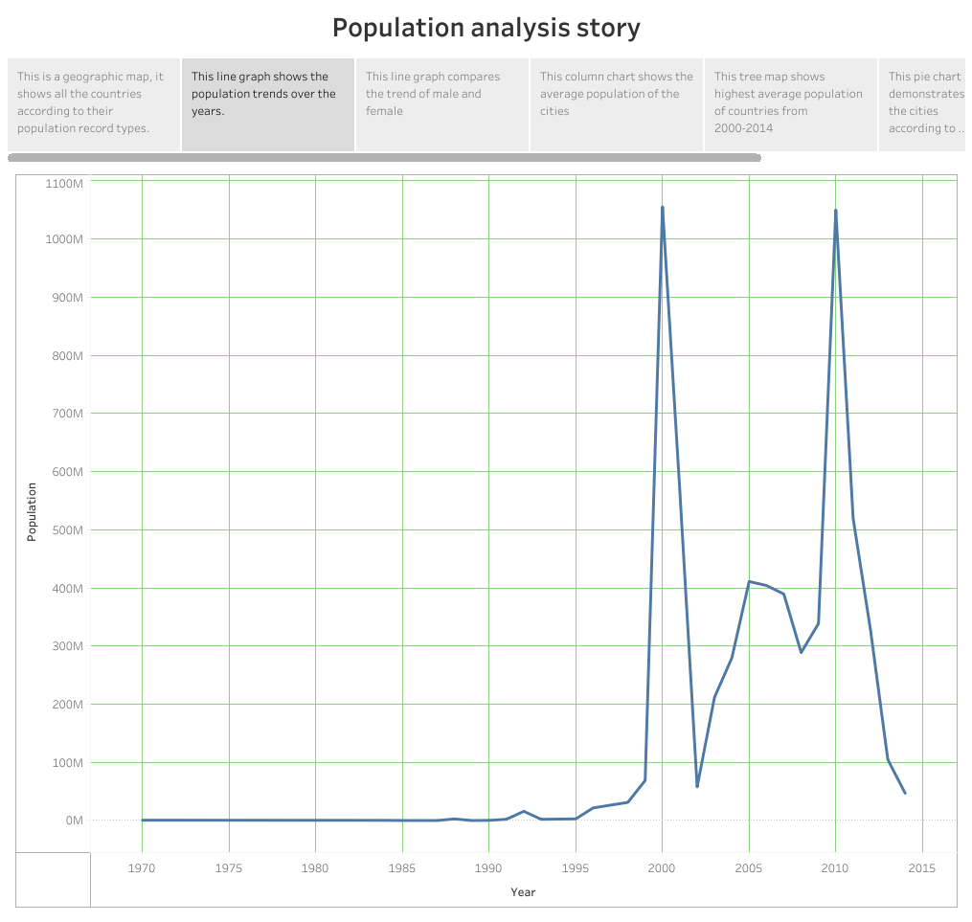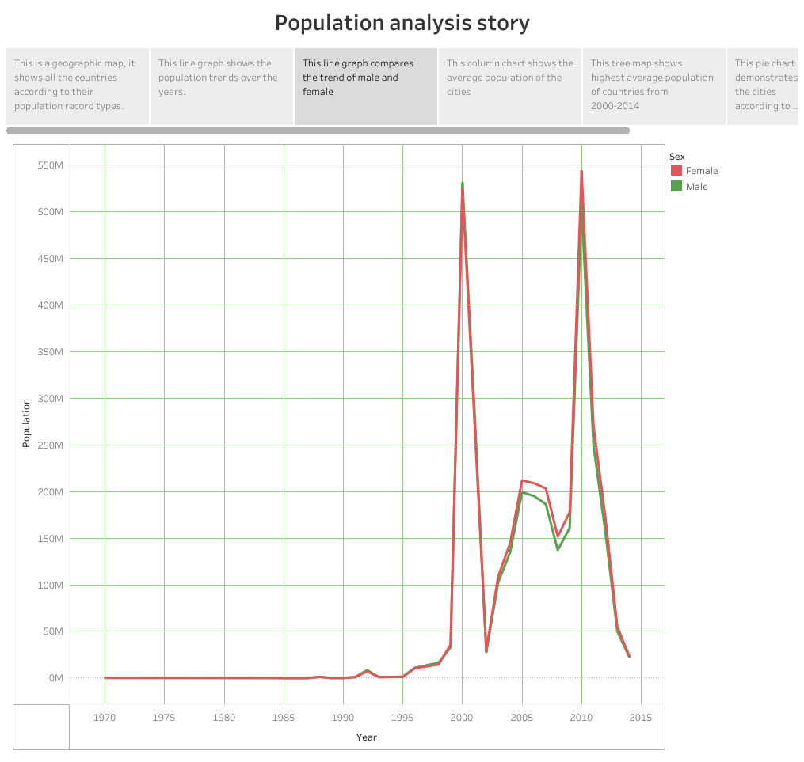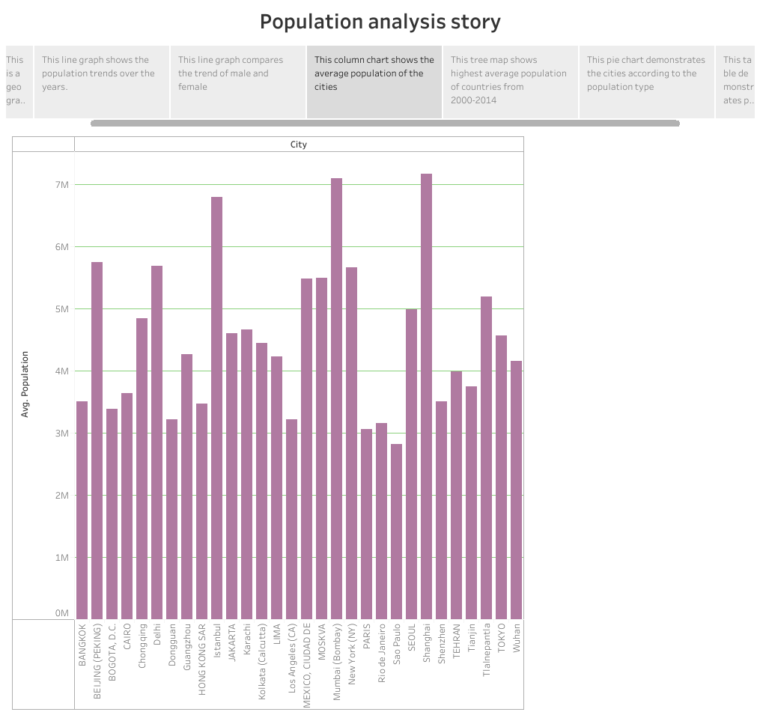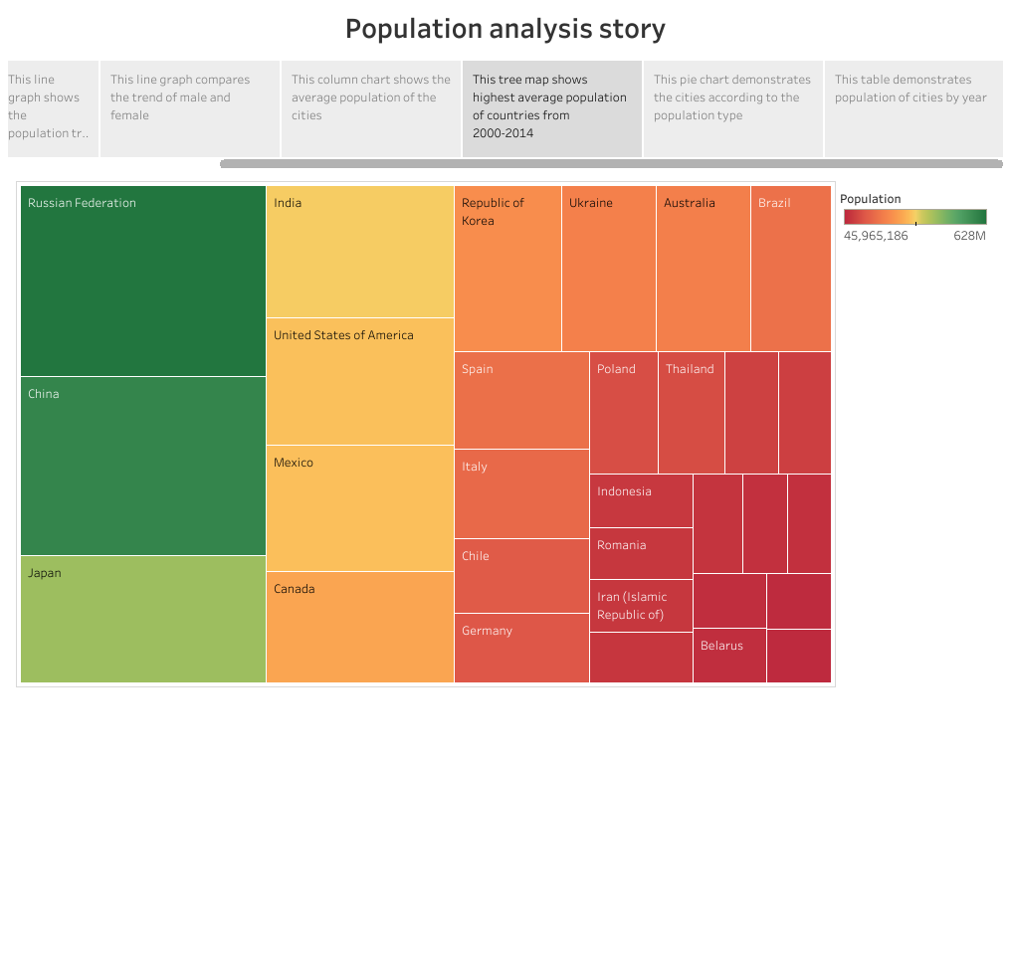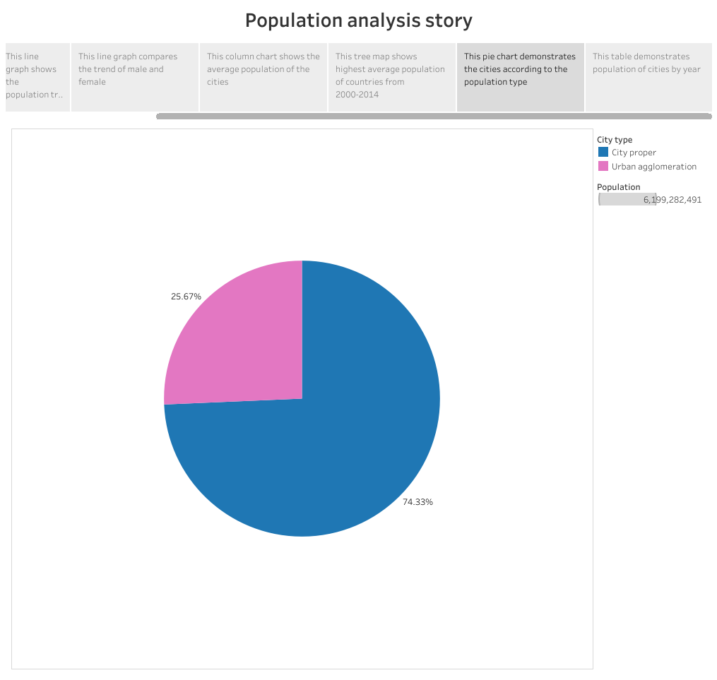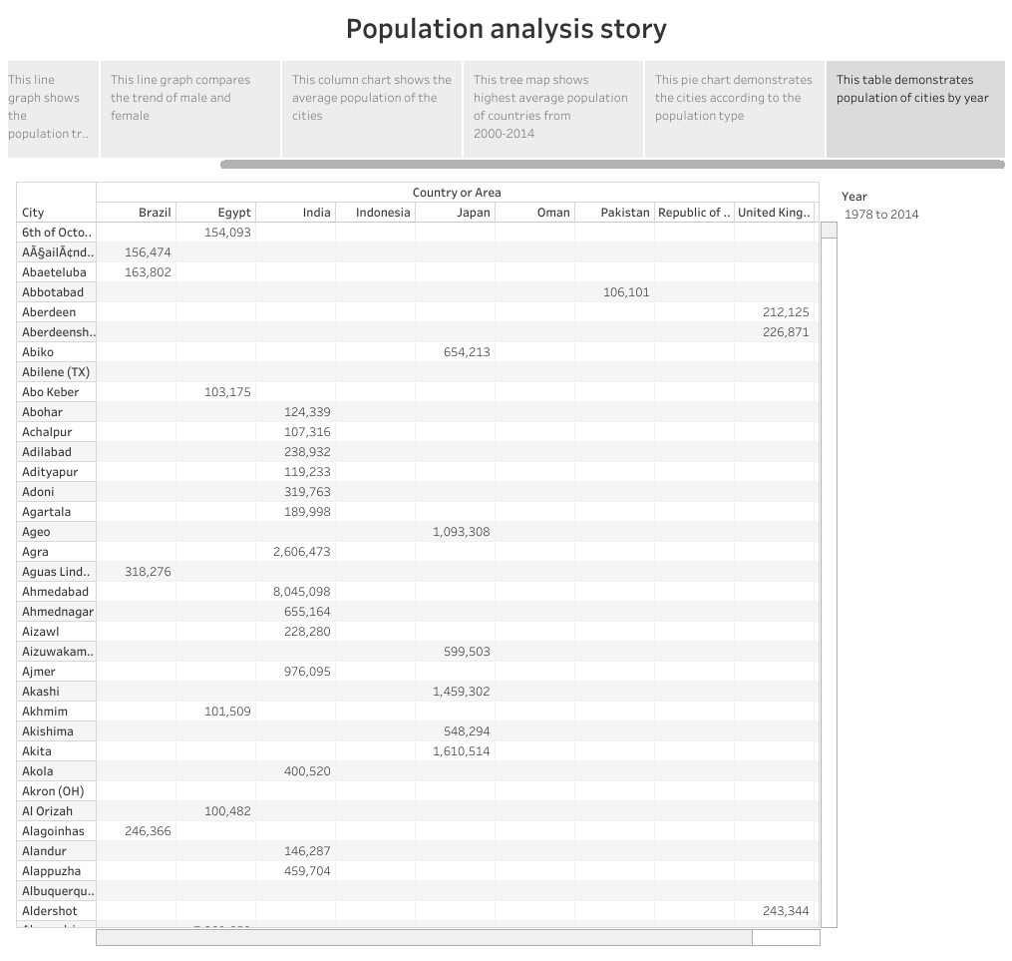

**4 ADVANTAGE AND DISADVANTAGE**

***Advantage:***

* Having cheaper and more readily available product and service.
* Reduce the fertility rate.
* Curbing population growth, aiding economic growth and improving the health and welfare of women &children.
* Enhance health by preventing unplanned pregnancy, abortions and sexually transmitted disease.
* More flexible labour market
* Increased economic output and living standards.
* Economic boost, low mortality rate increased innovation, etc…
* Provides many opportunities for businesses to capitalise on, given its vast consumer base.

***Disadvantage:***

* Ecological degradation, increased conflicts and a higher risk of large-scale disasters like pandemics.
* Unemployment/ increased dependency.
* 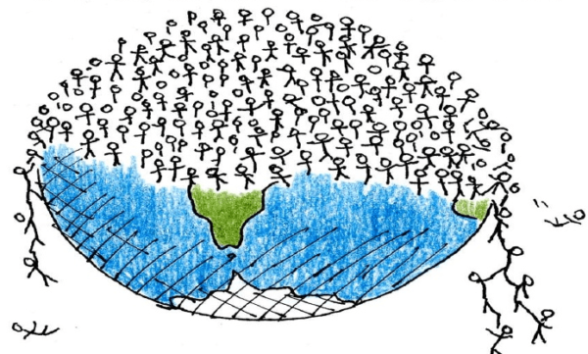The number of unproductive consumer is increasing.
* Low quality of life.
* Low per capita income.
* As the population increases there will be more chances for the exploitation of natural resources.
* Increased economic growth of a country growing demand for jobs, lack of housing and schools, lack of infrastructure leading to poor living and increase in pollution and waste.

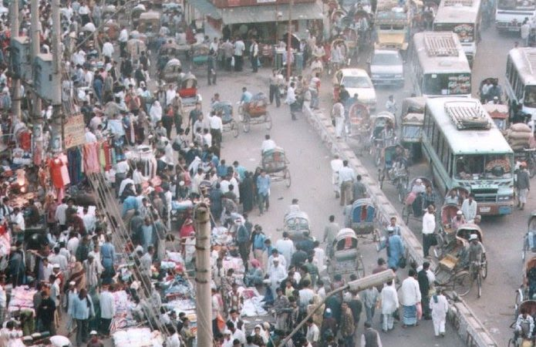

5 Applications

* 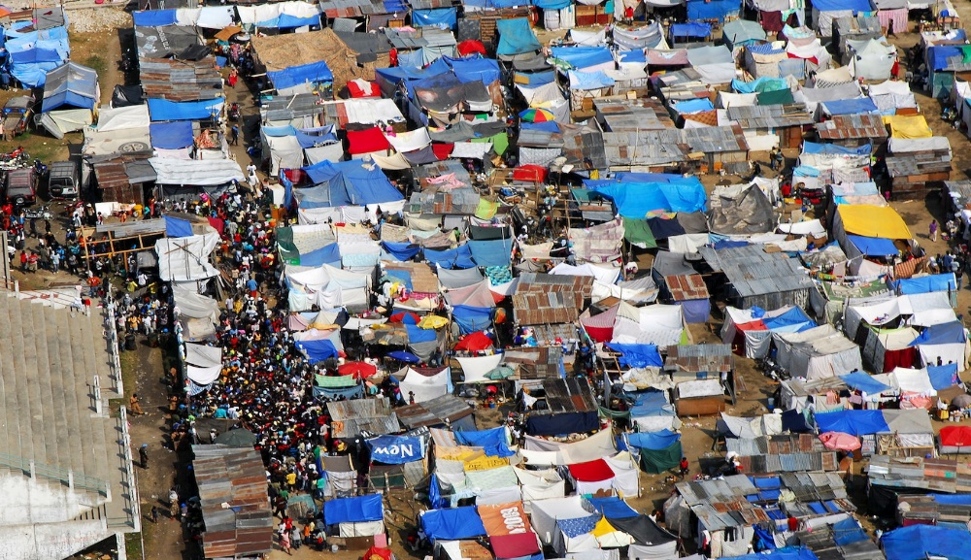More people means an increased demand for food, water, housing, energy, healthcare, transportation and more.
* Population growth will lead to economic growth with more people able to produce more goods.
* Population projection is important since it helps people that is government, researches, make decisions about the future.

**6 Conclusion**

* + 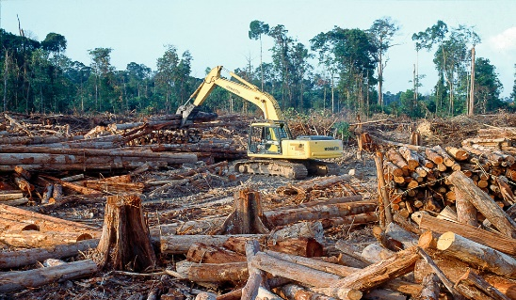Over population may cause a variety of problems including natural resource depletion, environmental pollution and degradation and loss of the natural environment.
  + People to have fewer children.
  + Promoting family planning.
  + 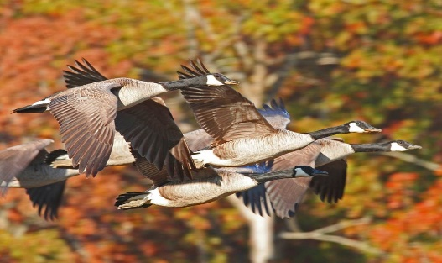Population density can be used to describe the location, growth and migration of many organisms.

**7 Future Scope**

*  The world’s population is expected to increase by nearly 2 billion persons in the next 30 years, from the current 8 billion to 9.7 billion in 2050 and could peak at nearly 10.4 billion in the mid-2080s.
* We would therefore expect growth to come to an end very soon after 2100.
* In this projection the world population will be around10.4 billion in 2100 and we would therefore expect peak population to occur late in the 21st century, at not much more than 10.4 billion.

**8 Appendix**

1. Source Code

<!DOCTYPE html>

<html lang="en">

<head>

  <meta charset="utf-8">

  <meta content="width=device-width, initial-scale=1.0" name="viewport">

  <title>iPortfolio Bootstrap Template - Index</title>

  <meta content="" name="description">

  <meta content="" name="keywords">

  <!-- Favicons -->

  <link href="assets/img/favicon.png" rel="icon">

  <link href="assets/img/apple-touch-icon.png" rel="apple-touch-icon">

  <!-- Google Fonts -->

  <link href="https://fonts.googleapis.com/css?family=Open+Sans:300,300i,400,400i,600,600i,700,700i|Raleway:300,300i,400,400i,500,500i,600,600i,700,700i|Poppins:300,300i,400,400i,500,500i,600,600i,700,700i" rel="stylesheet">

  <!-- Vendor CSS Files -->

  <link href="assets/vendor/aos/aos.css" rel="stylesheet">

  <link href="assets/vendor/bootstrap/css/bootstrap.min.css" rel="stylesheet">

  <link href="assets/vendor/bootstrap-icons/bootstrap-icons.css" rel="stylesheet">

  <link href="assets/vendor/boxicons/css/boxicons.min.css" rel="stylesheet">

  <link href="assets/vendor/glightbox/css/glightbox.min.css" rel="stylesheet">

  <link href="assets/vendor/swiper/swiper-bundle.min.css" rel="stylesheet">

  <!-- Template Main CSS File -->

  <link href="assets/css/style.css" rel="stylesheet">

  <!-- =======================================================

  * Template Name: iPortfolio

  * Updated: Mar 10 2023 with Bootstrap v5.2.3

  * Template URL: https://bootstrapmade.com/iportfolio-bootstrap-portfolio-websites-template/

  * Author: BootstrapMade.com

  * License: https://bootstrapmade.com/license/

  ======================================================== -->

</head>

<body>

  <!-- ======= Mobile nav toggle button ======= -->

  <i class="bi bi-list mobile-nav-toggle d-xl-none"></i>

  <!-- ======= Header ======= -->

  <header id="header">

    <div class="d-flex flex-column">

        <h1 class="text-light"><a href="index.html">Population</a></h1>

        <div class="social-links mt-3 text-center">

        </div>

      </div>

      <nav id="navbar" class="nav-menu navbar">

        <ul>

          <li><a href="#hero" class="nav-link scrollto active"><i class="bx bx-home"></i> <span>Visualizations</span></a></li>

          <li><a href="#resume" class="nav-link scrollto"><i class="bx bx-file-blank"></i> <span>Profile</span></a></li>

          <li><a href="#about" class="nav-link scrollto"><i class="bx bx-user"></i> <span>Story</span></a></li>

          <li><a href="#portfolio" class="nav-link scrollto"><i class="bx bx-book-content"></i> <span>Dashboard</span></a></li>

        </ul>

      </nav><!-- .nav-menu -->

    </div>

  </header><!-- End Header -->

  <!-- ======= Hero Section ======= -->

  <section id="hero" class="d-flex flex-column justify-content-center align-items-center">

    <div class="hero-container" data-aos="fade-in">

      <h8>...................TRACING THE GROWTH OF THE GLOBAL COMMUNITY:</h8>

      <h8>A POPULATION FORECASTING ANALYSIS</h8>

  </section><!-- End Hero -->

  <main id="main">

    <!-- ======= About Section ======= -->

    <section id="about" class="about">

      <div class="container">

        <div class="section-title">

          <h2>Story</h2>

        </div>

        <div class="row">

            <img src="assets/img/Story 1.png" class="img-fluid" alt="">

          </div>

          <section id="services" class="services section-bg">

            <div class="container" data-aos="fade-up"data aos-delay="200">

              <div class="row gy-5">

                <img class="fit picture"

                src="assets/img/Story 1 (2).png">

                <section id="services" class="services section-bg">

                  <div class="container" data-aos="fade up"data aos-delay="200">

                    <div class="row gy-5">

                      <img class="fit picture"

                      src="assets/img/Story 1 (3).png">

                      <section id="services" class="services section-bg">

                        <div class="container" data-aos="fade up"data data-aos-delay="200">

                          <div class="row gy-5"></div>

                          <img class="fit picture"

                          src="assets/img/Story 1 (4).png">

                          <section id="services" class="services section-bg">

                            <div class="container" data-aos="fade up"data data-aos-delay="200">

                              <div class="row gy-5">

                                <img class="fit picture"

                                src="assets/img/Story 1 (5).png">

                                <section id="services" class="services section-bg">

                                  <div class="container" data-aos="fade up"data data-aos-delay="200">

                                    <div class="row gy-5">

                                      <img class="fit picture"

                                      src="assets/img/Story 1 (6).png">

                                      <section id="services" class="services section-bg">

                                        <div class="container" data-aos="fade up"data data-aos-delay="200">

                                          <div class="row gy-5">

                                            <img class="fit picture"

                                            src="assets/img/Story 1 (7).png">

                                          </div>

                                        </div>

                                      </section>

                                    </div>

                                  </div>

                                </section>

                            </div>

                        </div>

                      </section>

                    </div>

                  </div>

                </section>

            </div>

          </section>

          <div class="col-lg-8 pt-4 pt-lg-0 content" data-aos="fade-left">

            <div class="row">

              <div class="col-lg-6">

                <ul>

              </div>

            </div>

          </div>

        </div>

      </div>

    </section><!-- End About Section -->

    <!-- ======= Resume Section ======= -->

    <section id="resume" class="resume">

      <div class="container">

        <div class="row">

          <div class="col-lg-6" data-aos="fade-up">

            <h3 class="resume-title">Title</h3>

            <div class="resume-item pb-0">

              <h4>Tracing the Growth of the Global Community:A Population Forecasting Analysis</h4>

              <p><em>The world's population is more than three times larger than it was in the mid-twentieth century.The global human population reached 8.0 billion in the mid-November 2022 from an estimated 2.5 billion people in 1950,adding 1 billion people since 2010 and 2 billion since 1998.The world's population is expected to increase by nearly 2 billion persons in the next 30 years,from the current 8 billion to 9.7 billion in 2050 and could peak at nearly 10.4 billion in the mid-2080s.</em></p>

              This dramatic growth has been driven largely by increasing numbers of people surviving to reproductive age,the gradual increase in human lifespan,increasing urbanization, and accelerating migration. Major changes in fertility rate have accompanied this growth.These trends will have far-reaching implications for generations to come.

              <section id="services" class="services section-bg">

                <div class="container" data-aos="fade up"data data-aos-delay="200">

                  <div class="row gy-5">

                    <img class="fit picture"

                    src="assets/img/portfolio/population pic.jpg">

                  </div>             </div>

              </section>

                  </div>

                </div>

              </section>

            </div>

          </div>

        </div>

      </div>

    </section><!-- End Resume Section -->

    <!-- ======= Portfolio Section ======= -->

    <section id="portfolio" class="portfolio section-bg">

      <div class="container">

        <div class="section-title">

          <h2>Dashboard</h2>

          <section id="services" class="services section-bg">

            <div class="container" data-aos="fade up"data data-aos-delay="200">

              <div class="row gy-5">

                <img class="fit picture"

                src="assets/img/Dashboard 1.png">

                <section id="services" class="services section-bg">

                  <div class="container" data-aos="fade up"data data-aos-delay="200">

                    <div class="row gy-5">

                      <img class="fit picture"

                      src="assets/img/Dashboard 2.png">

                  </div>

                </section>

          </section>

  </main><!-- End #main -->

  <a href="#" class="back-to-top d-flex align-items-center justify-content-center"><i class="bi bi-arrow-up-short"></i></a>

  <!-- Vendor JS Files -->

  <script src="assets/vendor/purecounter/purecounter_vanilla.js"></script>

  <script src="assets/vendor/aos/aos.js"></script>

  <script src="assets/vendor/bootstrap/js/bootstrap.bundle.min.js"></script>

  <script src="assets/vendor/glightbox/js/glightbox.min.js"></script>

  <script src="assets/vendor/isotope-layout/isotope.pkgd.min.js"></script>

  <script src="assets/vendor/swiper/swiper-bundle.min.js"></script>

  <script src="assets/vendor/typed.js/typed.min.js"></script>

  <script src="assets/vendor/waypoints/noframework.waypoints.js"></script>

  <script src="assets/vendor/php-email-form/validate.js"></script>

  <!-- Template Main JS File -->

  <script src="assets/js/main.js"></script>

</body>

</html>

***THANK YOU***